|  |  |  |  |
| --- | --- | --- | --- |
| QFO-AP-VA-008 | **رمز النموذج:** | **اسم النموذج: خطة المادة الدراسية** | **جامعة فيلادلفيا**    Philadelphia  University |
| 2 | **رقم الإصدار: )Rev(** | **الجهة المصدرة:** نائب الرئيس للشؤون الأكاديمية |
| 2021-5-4 | **تاريخ الإصدار:** | **الجهة المدققة: اللجنة** العليا لضمان الجودة |
| 4 | **عدد صفحات النموذج:** |

|  |  |  |  |  |  |  |  |  |  |
| --- | --- | --- | --- | --- | --- | --- | --- | --- | --- |
| **Course Title:**  Network Operating Systems | | |  | **Course code:** 0790420 | | | | | |
|  | | |  | **Course prerequisite(s) and/or corequisite(s):** | | | | | |
| **Course Level:** 3 | | |  | 0790323 Linux Operating Systems | | | | | |
| **Lecture Time:** 08:15 am – 09:05 am | | |  | **Credit hours:** 3 | | | | | |
|  | **UR** | **FR** | **DR** |  |  |  | **SR** | **E** |  |
|  |

**Academic Staff Specifics**

|  |  |  |  |  |
| --- | --- | --- | --- | --- |
| **Name** | **Rank** | **Office**  **Number and**  **Location** | **Office Hours** | **E-mail Address** |
| Maram Bani Younes | Associate Professor | 318  IT College | 09:05 – 09:55 am | mbaniyounes@philadelphia.edu.jo |

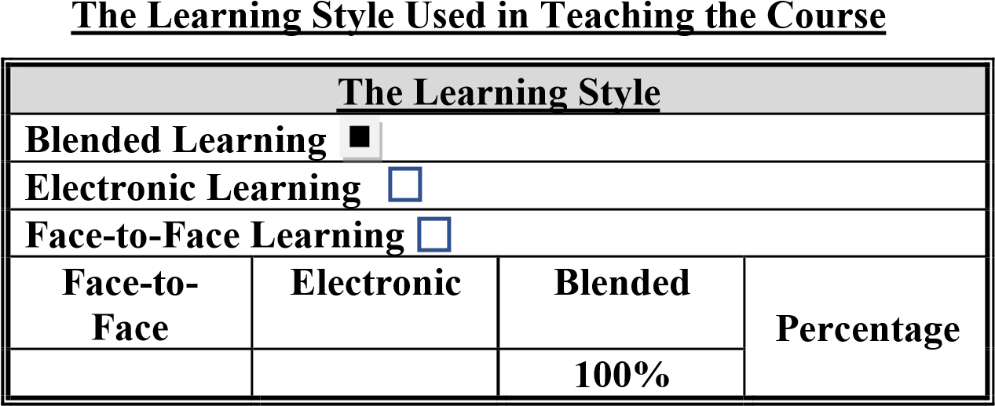

**Course Description:**

A Network Operating Systems course is designed to provide students with a comprehensive understanding of the configuration and management of network operating systems used in modern computer networks. This course covers topics such as network protocols, network security, and network administration. Students will learn how to install, configure, and troubleshoot network operating systems such as Windows Server and Linux Server. They will also learn about the different network services, GPOs and protocols such as DNS, DHCP, TCP/IP, and LDAP. Throughout the course, students will have the opportunity to develop their hands-on skills through lab exercises and practical assignments.

**Course Objectives:**

The objective of this course is to cover fundamental network administration and system management. Topics to be covered include: accessing and configuring basic network services, managing directory services, and using network management software on heterogeneous operating system platforms. Students should be able to apply system administrator skills in developing a network management strategy from installation, configuration and administration of Network Operating Systems. The course has Hands-on Linux server and Windows server practice that ensures job-ready on the first day of new network or systems administrator.

**Course Components**

* Getting started with network operating systems
* Directory Services
* Managing network accounts and permissions
* Managing environment of users and computers using Group Policies
* Installing and configuring main network services
* Managing Storage Volumes
* Monitoring network system resources
* Securing servers and their operating systems

**Textbooks:**

1. Mastering Linux System Administration, Christine Bresnahan and Richard Blum, 2021
2. Windows Server 2022 Administration Fundamentals, 3rd Edition, Bekim Dauti, Packt 2022
3. Mastering Ubuntu Server, 4th Edition, Jay LaCroix, Packt 2022

*In addition to the above, the students will be provided with handouts by the lecturer.*

**Teaching Methods:**

Duration: 16 weeks, 48 hours in total

Lectures: 32 hours, 2 per week (including two 1-hour midterm exams)

Tutorials: 16 hours, (1 hour per week) + 16 hours Laboratory Homework: 8 assignments

**Learning Outcomes:**

1. **Knowledge and understanding**

A2- Discuss the wide range of NOS technologies, and managing tools

A3- Understand professional scenarios of deploying NOS and network services

A4- Identifies the needs of building secure NOS environment of clients and servers A5- Identify professional certification in the labor market; like Server+ and LPIC

1. **Cognitive skills (thinking and analysis).**

B2- Assess gaps and weaknesses in NOS, services and networks

B3- Estimate the case of handling damage resulting from attacks on NOS

B4- Evaluates appropriate tools and techniques to treat damage caused by security breaches

B6- Skilled for self-learning to be ready for professional certifications; like Linux+ and LPIC

1. **Communication skills (personal and academic).**  C1- Apply different protocols for network services

C2- Apply the principles of design, development, and management NOS

C3- Uses various networking and services protocols over NOS

C4- Construct secure environment of NOS and networks

C7- Operate solutions for various types of troubles on NOS and networks C8- Monitoring the performance of NOS

1. **Practical and subject specific skills (Transferable Skills).**

D4, D5, D7- Display the ability to work as group and show the personal responsibilities.

**Learning outcomes achievement:**

**Development:** A2, A3, A4, and A5 are developed through lectures and home works.

B2, B3, B4, and B6 are developed through tutorial and home works.

C1, C2, C3, C4, C7, and C8 are developed through tutorial and home works.

D4, D5, and D7 are developed through assignments and essays.

**Assessment:** A2, A3, B1, B2, and B3 are assessed through quizzes and written exams.

C1, C2, C3, D4- D7 are assessed through projects, home works, and assignments.

**Assessment Instruments**

|  |  |
| --- | --- |
| **Allocation of Marks** |  |
| **Assessment Instruments** | **Mark** |
| Mid examination | **30%** |
| 2-hours Final Examination | **40%** |
| Reports, Assignments, Quizzes, Home works, Projects | **30%** |
| Total | **100%** |

*\* Make-up exams will be offered for valid reasons only with consent of the Dean. Make-up exams may be different from regular exams in content and format.*

**Mid Exam**

*At the 9th week:*

***Section 1:*** *second week of May 2023*

**Practical Submissions**

*The assignments that have work to be assessed will be given to the students in separate documents including the due date and appropriate reading material.* Submit your home work through Teams. After the deadline

“zero” will be awarded.

**Course/Module Academic Calendar**

|  |  |  |
| --- | --- | --- |
| **Week** | **Basic and support material to be covered** | **Homework/reports and their due dates** |
| **(1)** | Getting started with network operating systems | Assignment 1 |
| **(2)** |
| **(3)** | Directory Services | Assignment 2 |
| **(4)** |
| **(5)** | Managing network accounts and permissions | Assignment 3 |
| **(6)** |
| **(7)** | Managing environment of users and computers using Group Policies |  |
| **(8)** |
| **(9)** | Installing and configuring main network services | Assignment 4 |
| **(10)** |
| **(11)** | Managing Storage Volumes | Assignment 5 |
| **(12)** |
| **(13)** | Monitoring network system resources | Assignment 6 |
| **(14)** |
| **(15)** | Securing servers and their operating systems |  |
| **(16)** |

**Expected workload:**

On average students need to spend 2 hours of study and preparation for each 50-minute lecture/tutorial.

**Attendance policy:**

Absence from lectures and/or tutorials shall not exceed 15%. Students who exceed the 15% limit without a medical or emergency excuse acceptable to and approved by the Dean of the relevant college/faculty shall not be allowed to take the final examination and shall receive a mark of zero for the course. If the excuse is approved by the Dean, the student shall be considered to have withdrawn from the course.